Submitted To: Ivan Wong

Submitted By:

Bao Vuong Chi (300301875)

Navneet Kaur (300294398)

Shankarenfo Pannagiani Dharma (300304800)

Varun Saini (300292468)

CSIS 3275-Software Engineering

Project Final Report

**Spring MVC based Cloths Online Shopping System**

**Web Application**

**Due Date: 04/09/2020**

# Introduction

The Cloths Online Shopping is a web-based application intended for online retailers. The main objective of this application is to make searching, viewing and selection of product easier. It contains a sophisticated search engine for users to search for products specific to their needs. The search engine provides an easy and convenient way to search for products where users can search for a product interactively and the searching engine would refine the products available based on the users inputs, the users can then view the complete specification of each product. In Cloths Online Shopping System if an intermediary service is present the process is called Electronic Commerce (e-commerce).

## Project Objective

The objective of the project is to make web-application to purchase cloths in an existing shop through online. In order to build such an application complete web support need to be provided. A complete and efficient web application which can provide the online shopping experience is the basic objective of the project. The main aim of this application is to allow the customers to shop virtually using the internet and allow customers to buy the cloths of their desire from the store.

## Scope

This project traverses a lot of areas ranging from business concept to computing field and required to perform several research to able to achieve the project objectives. The areas cover include:

* Online Shopping Industry: This includes study on how the online cloths shopping business is being done, process involved and opportunity that exist for improvement.
* Spring MVC, maven, JSP &JDBC technology used for the development of the application.
* General customers as well as the company’s staff will be able to use the system effectively.
* Web-platform means that the system will be available for access 24/7 except when there is a temporary server issue which is expected to be minimal.

## Tools & Technology

We have used the following technologies:

* HTML5/Spring MVC framework/Maven: This is used for the client side and look and feel of the web application. Since the client will be fully responsive, it will work seamlessly across all platforms (Mobile devices and desktop)
* Java/JSP (Java Server Page)/Servlets & JDBC (Java Database Connectivity): This is used on the server side and will be the middleware between Client Side and Database.
* MYSQL Database: This is where all data will be stored. Passwords will be hashed for security.

## Process Flow

For our process flow, we planned on taking the iterative route, as we find communication essential throughout the development process. In order to plan all aspects of the project in detail, we feel that contacting the online shopping service and having those in charge be in the same room when the planning is taking place. It is our way of discussing requirements and develop important notes that will help in constructing the overall feel and idea. The process in its own right, we feel is not a start to finish process. There will be times that we may have to go back certain portions within modeling activity to ensure a enough model.

Lastly, we find the construction framework activity to require communication with the online shopping service as well. It would allow for us to get the testing process on the interaction between constructed elements and those that will use the software directly. We feel that allowing for the users to view how the software is made will ease the transition during deployment stage.

# Executive Summary

## How Online Cloths Shopping System Works

The Online Cloths Shopping System is going to be solely implemented for customers and admin. In detail, the main function of the system is to register and store user detailed record. This system will facilitate the functioning of web-based Online Cloths Shopping System. Each type and brands of cloths are available at affordable price. The discounts are also available at certain occasions. The system has following functionalities:

Search and filter: customers can search and filter variety of cloths according to their choice. The cloths are of good quality. This system is equipped to answer customer’s inquiries about the availability and price of various types of cloths.

Add To Cart: After searching and selection of cloths customers can add all the selected items in cart. They can also remove the items from cart.

Make Payment: Customers can do the payments with credit card. They can get the reference number of their purchase, can also get receipt.

## Modules and Methods

The Application have two user roles:

1. Admin
2. Customers

### Customer

* Create account
* Manage self account
* Browse shop inventory
  + Filter/Search inventory
* Make orders
  + Add items to cart (batch purchase)
  + Set destination address
  + Confirm purchase
* Review ongoing orders
* Cancel orders

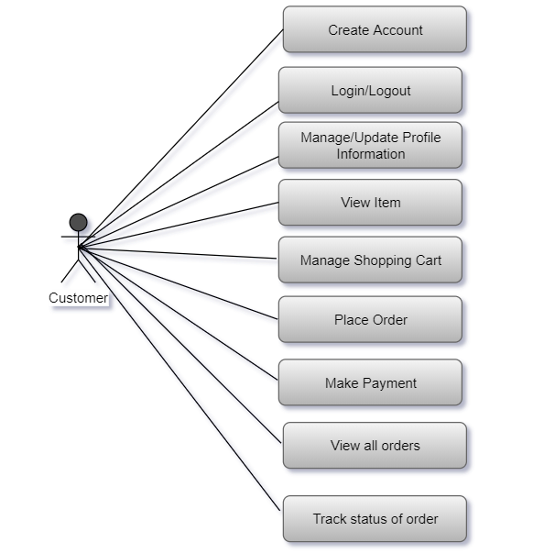

### Admin

* Manage store inventory
  + Add, edit, delete clothing items
  + Add, edit, delete clothing categories
* Edit registered users’ data
* Review sales records
  + Item sale statistics
  + Total shop profits
  + Previous sale records

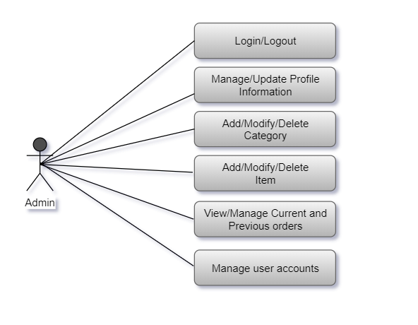

Advantages of Online Cloths Shopping System

* This online car rental solution is fully functional and flexible.
* It is very easy to use.
* It helps in back office administration by streamlining and standardizing the procedures.
* It saves a lot of time, money and labor.
* Eco-friendly: The overall business becomes easy and includes the least of paperwork.
* The software acts as an office that is open 24/7.
* It increases the efficiency of the management at offering quality services to the customers.
* It provide custom features development and support with the software.

# Installation

## Design and Implementation Constraints

* The software will use HTML5/CSS/JSP/Spring MVC/Servlets as main web technologies.
* HTTP and FTP protocols are used as communication protocols. FTP is used to upload the web application in live domain and the client can access it via HTTP protocol.
* Several types of validations make this web application a secured one.
* Since Online Cloths Shopping System is a web-based application, internet connection must be established.

## Assumptions and Dependencies

### Regularity Policies:

Each center has account created and authenticated by admin. This website can be accessible within company’s intranet and other user can see all details about the franchisee. Each user has to first login to present him/her after entry in franchisee. This will be done automatically, no user can share their username and password to each other.

### Hardware Limitation:

There is no limitation in the operating system in which Online Cloths Shopping System will work. However, the Online Cloths Shopping System and the database will work on a server that needs to be always online. Users can access the system with any internet browser.

# User Manual

## Functional Requirements

Requirement analysis is a software engineering technique that is composed of the various tasks that determine the needs or conditions that are to be met for a new or altered product, taking into consideration the possible conflicting requirements of the various users.

Functional requirements are those requirements that are used to illustrate the internal working nature of the system, the description of the system and explanation of each subsystem. It consists of what task the system should perform, the process involved, which data should the system holds and the interfaces with the user. The functional requirements identified are:

* **Customer’s registration:** The systemshould allownew users to register online.
* **Authenticate User:** This web-application provide secure login.
* **Automatic update to database once purchase is made or new customer registered:**

Whenever there’s new purchase or new registration, the system should be able to update the database without any additional efforts from the admin.

* **Feedbacks to customers:** It should provide means for customers to leave feedbacks.

## Non-Functional Requirements

It describes aspects of the system that are concerned with how the system provides the functional requirements. They are:

* **Security:** The subsystem should provide a high level of security and integrity of the data held by the system, only authorized personnel of the company can gain access to the company’s secured page on the system and only users with valid password and username can login to view user’s page.
* **Performance and Response Time:** The system should have high performance rate when executing user’s input and should be able to provide feedback or response within a short time span usually 50 seconds for highly complicated task and 20 to 25 seconds for less complicated task.
* **Error Handling:** Error should be considerably minimized and an appropriate error message that guides the user to recover from an error should be provided. Validation of user’s input is highly essential. Also, the standard time taken to recover from an error should be 15 to 20 seconds.
* **Availability:** This system should always be available for access at 24 hours, 7 days a week. Also in the occurrence of any major system malfunctioning, the system should be available in 1 or 2 working days, so that the business process is not severely affected.
* **Ease of use:** Considered the level of knowledge possessed by the users of this system, a simple but quality user interface should be developed to make it easy to understand and required less training.

# Software Description

The web application will allow for customers to buy cloths either by browsing or searching directly. The customer can register to save any information they may input during the payment/checkout process or they can log in to use any previous information they provided with the company already.

The software the company employees will use a user interface to view, edit and modify the customer information, customer requests, payments and product information. The employee will also have the ability to search customer and product information as well as print out any reports that may be necessary.

## How to Use the Software

The web application designed for the customers of the online shopping service should see the main page upon entering the URL into the address bar. There they can see the features and variety of cloths as well as clearly identify the search options. Upon searching and clicking a item, they would be directed to a page with more description on cloths. It is at this page the user can click the button to add to cart. The user will input card information which will be securely transferred and verified by the company and the processing will begin on the company’s end.

The software when opened will split into two main sections: the active real-time customer processing that the employee is assigned to and searching/browsing section. The real-time section will have alerts that the employee can click to view in detail on when customers that have successfully checked-out need their purchases and how. The searching section is subdivided into three main sections: total payment reports, customer information and item information. When the section is clicked, the customer will be taken to a new page with a more detailed report of what they are searching. Reports may not be modified, only printed and search for specific payments. Customer information and item information can be modified however, with edit buttons next to each sub section (description, name etc.). There is remove button in shopping cart to remove the item from cart. Clear cart button is to clear the shopping cart.

# Troubleshooting Common Problems

## The website

**Problem:** Loading incorrectly/Session has Timed Out

* Make sure internet is working properly.
* Clear browser’s cache and re-launch the browser.

**Problem:** Invalid Login

* The credentials used to login was not found in the database, input the credentials again in case of mistype
* If invalid login persists, pursue the lost password option to obtain a new password.

**Problem:** Page not found

* Make sure you have entered the URL correctly.

## The Software

**Problem:** Customer requests for items are being delayed by significant amount.

* Make sure the internet is working properly, most of the time the case is the internet connection either used by the company or the customer themselves.
* If the problem persists, contact someone of higher authority who can verify if the server is having down time issues. It may need to be waited out before the problem can continue.

**Problem:** Customer/Product not found

* Upon searching through the software, this means that customer or product is not currently in the database or may have been removed. Review recent changes to the database by the company to see if any changes had occurred.

# UI of the Software

The main url Page

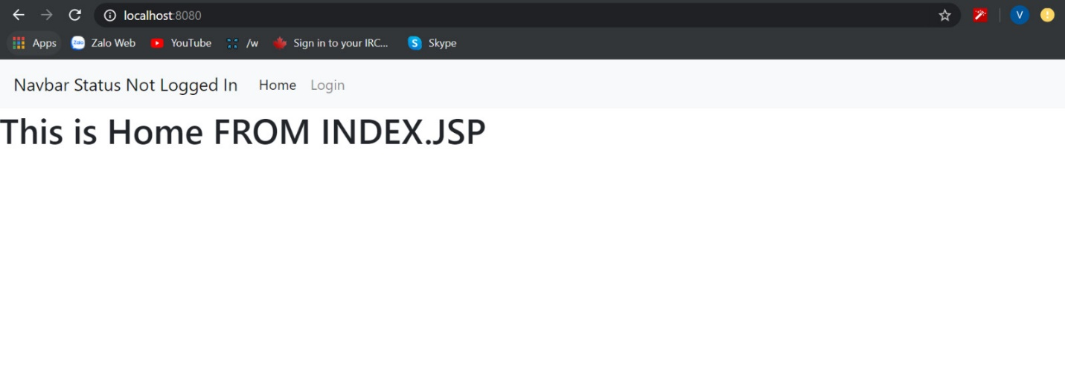

Login Page

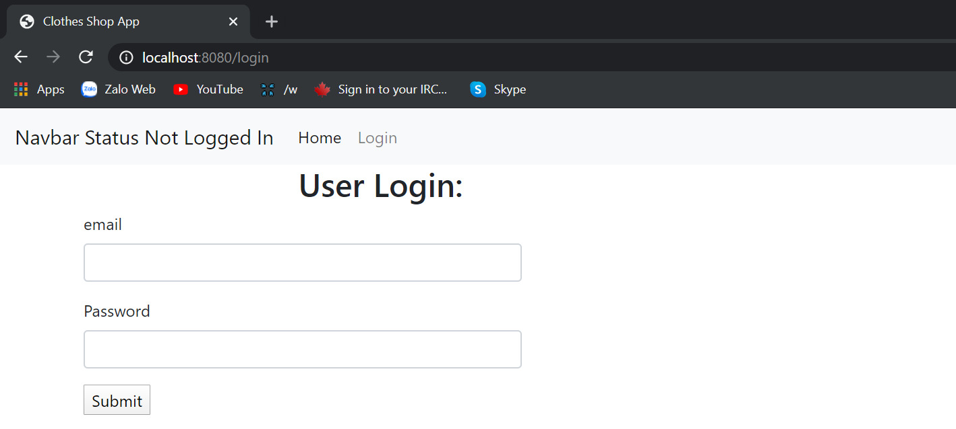

User Listing

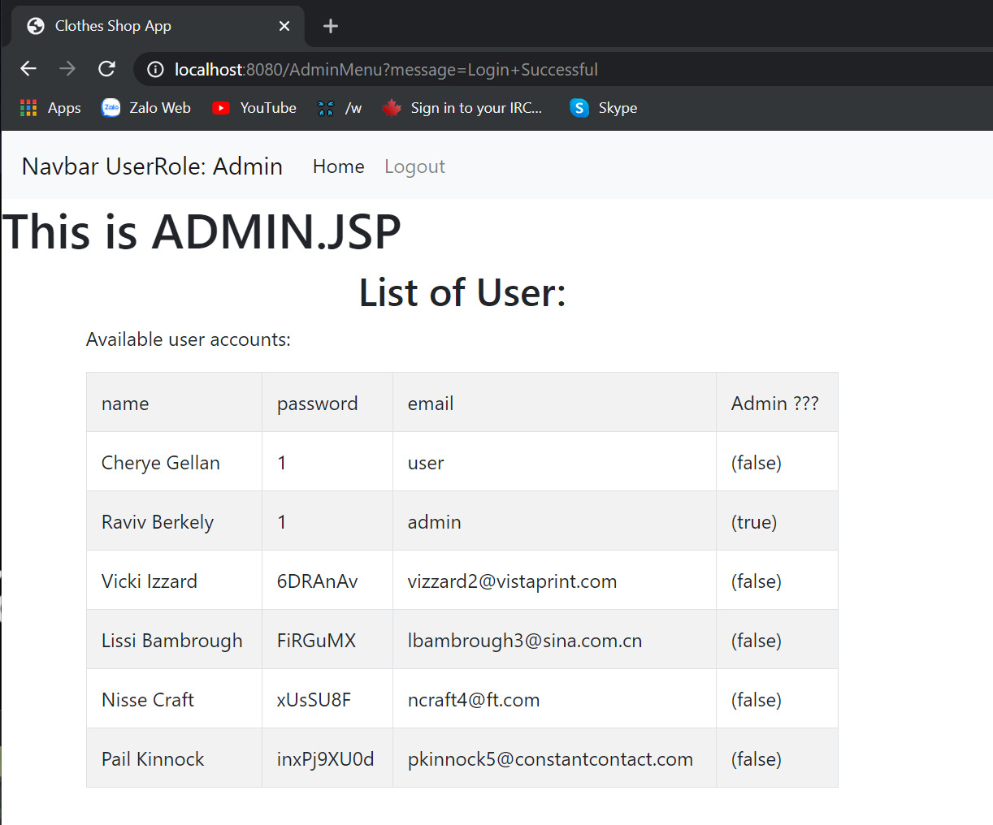

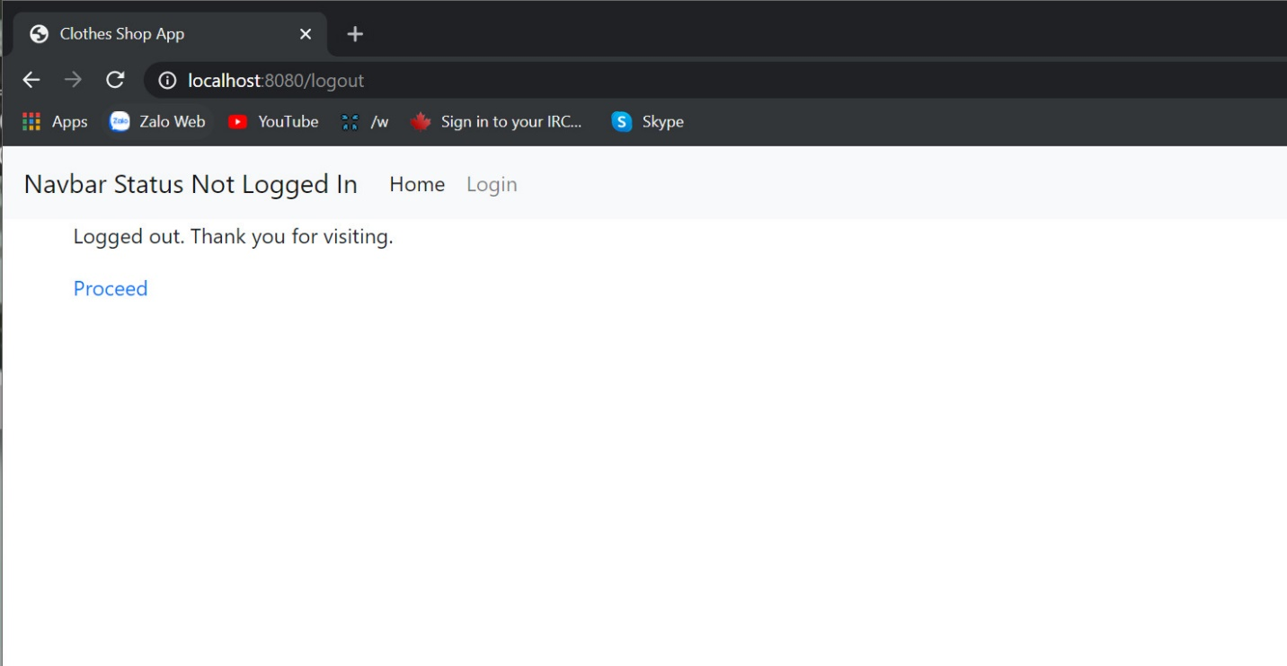Log Out

Login Success

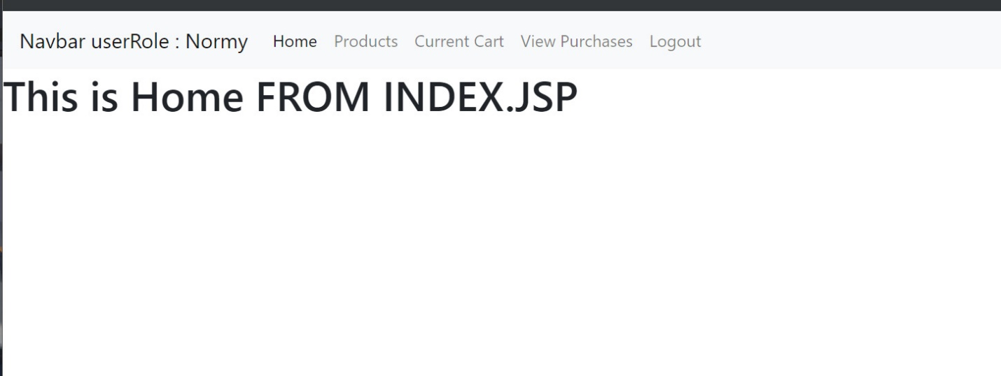

Product Listing

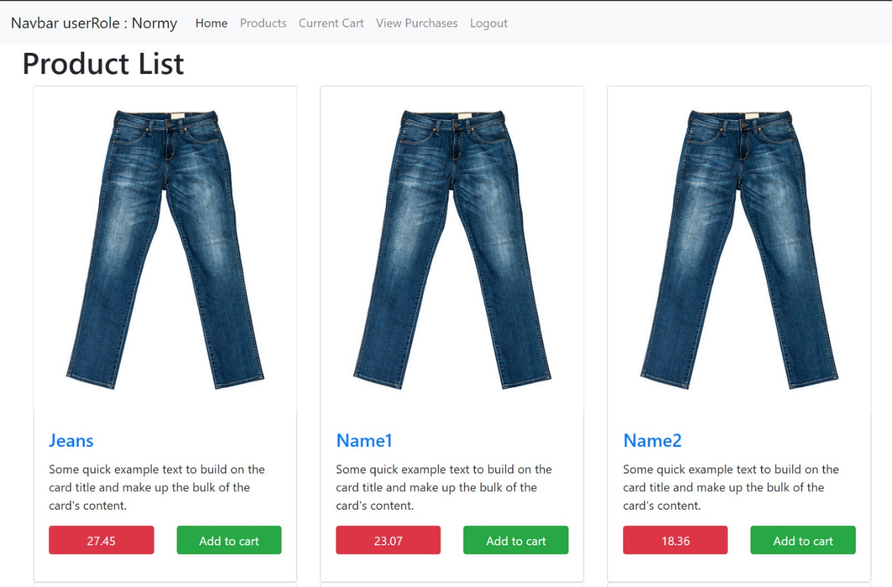

Add to Cart

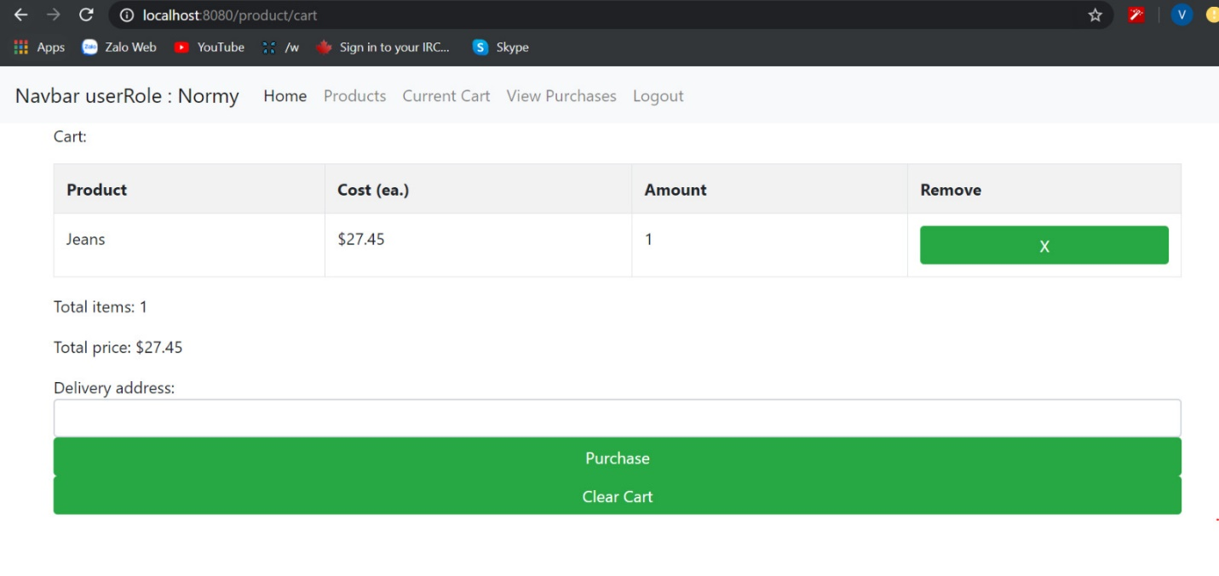

Purchase

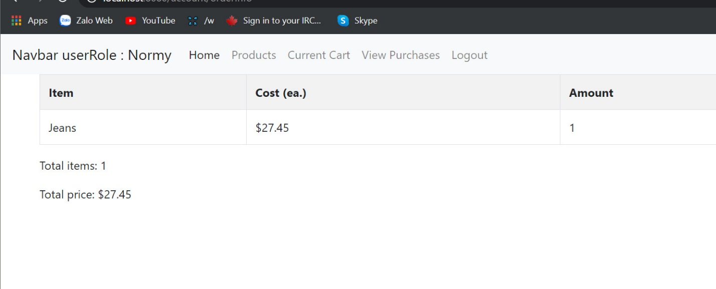

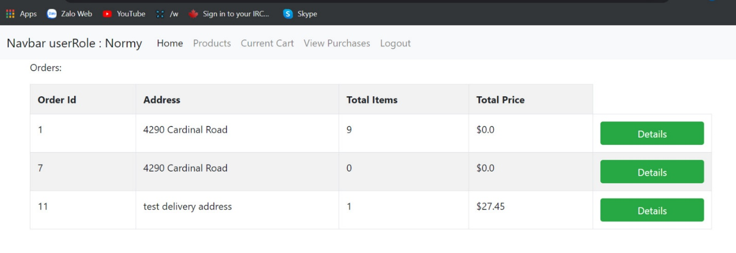User Purchases

Conclusion

The development of the software includes many modules such as user system developer, user of the system and the administration system developer. It is important to identify the system requirements by properly collecting required data to interact with the system. This project helped us in gaining valuable information and practical knowledge on several topics such as designing web pages using jsp(java servlet pages), html, css, designing of responsive templates, usage of spring MVC and management of database using mysql as well JDBC. The project also helped us understanding about the development phases of project and software development life cycle.

This project has given us great satisfaction in having designed an application which can be implemented to any nearby shops or branded shops selling various brands of cloths by simple modifications.

Project Log

|  |  |  |  |
| --- | --- | --- | --- |
|  | **Tasks** | **Members Involved** | **Description** |
| Jan 06 | Meeting for proposal | Bao Vuong Chi,  Navneet Kaur,  Shankarenfo Pannagiani Dharma,  Varun Saini | Cloths Online Shopping System and selecting possible name for project.  (30 mins) |
| Jan 13 | Meeting for proposal | Bao Vuong Chi,  Navneet Kaur,  Shankarenfo Pannagiani Dharma,  Varun Saini. | Discussion about project planning phase. (40 mins) |
| Jan 20 | Writing proposal | Bao Vuong Chi,  Navneet Kaur, | Writing proposal (40 mins) |
| Jan 23 | Polishing Proposal | Shankarenfo Pannagiani Dharma,  Varun Saini. | Checking mistakes and make corrections. (40 mins) |
| Feb 20 | Interim Discussion | Bao Vuong Chi,  Navneet Kaur,  Shankarenfo Pannagiani Dharma,  Varun Saini. | Discussion of Interim report contents, UI design, Plan B. |
| Mar 2 | Week Planning | Bao Vuong Chi, Navneet Kaur,  Shankarenfo Pannagiani Dharma | Weekly planning- task assignment |
| Mar 7 | Week Overview | Bao Vuong Chi, Varun Saini,  Shanka P. Dharma | Database discussion, Interface flow rework. |
| Mar 15 | Project Progress | Bao Vuong Chi,  Navneet Kaur,  Shankarenfo Pannagiani Dharma,  Varun Saini. | MVC discussion,  Working on project’s main features |
| Mar 23 | Modification in project work | Bao Vuong Chi,  Navneet Kaur,  Shankarenfo Pannagiani Dharma,  Varun Saini. | Changes in project’s functions, |
| Mar 31 | Work on more functions | Shankarenfo Pannagiani Dharma | Adding more functions in project. |
| April 2 | Work on Report | Bao Vuong Chi,  Navneet Kaur,  Shankarenfo Pannagiani Dharma,  Varun Saini. | Final project report |
| April 6 | Changes in report | Bao Vuong Chi,  Navneet Kaur,  Shankarenfo Pannagiani Dharma,  Varun Saini. | Modifications in report |
| April 7 | Presentation | Bao Vuong Chi,  Navneet Kaur,  Shankarenfo Pannagiani Dharma,  Varun Saini. | Working on project presentation |
| April 8 | Review | Bao Vuong Chi,  Navneet Kaur,  Shankarenfo Pannagiani Dharma,  Varun Saini. | Final review on project, report and presentation |

Alongside these listed meeting hours, we also had frequent informal discussions using whatsapp and mobile messages/calls to facilitate our planning. Most ‘meetings’ listed after March are done this way due to the coronavirus.